Brynteg CP School
Equality Action Plan

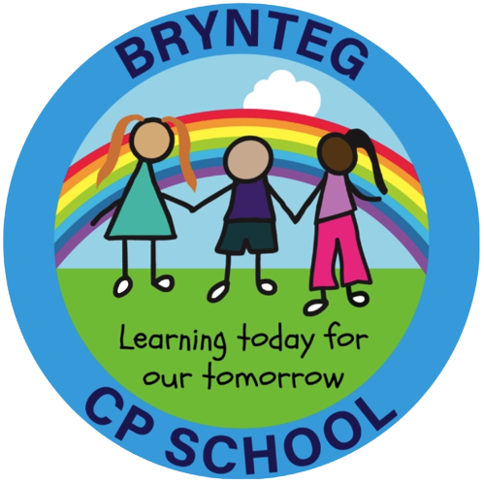

Approvals
Approved by Governing Body | January 2026
Review date for Governing Body | January 2027

Annual Priorities (linked to the 4 Equality Objectives)

Equality Objective 1:

Promote understanding of the protected characteristics and embed equality across school life.

Equality Objective 2:

Ensure progress and wellbeing outcomes are equitable across all groups, including those with protected characteristics.

Equality Objective 3:

Increase awareness of equality and diversity among pupils, staff and governors.

Equality Objective 4:

Ensure school policies, procedures and practices reflect the Equality Act and support inclusion.

1. Annual Action Plan

Strategically Planned Tasks | Lead Person(s) | Timescale | Success Criteria | Monitoring Arrangements
Deliver staff training on the Equality Act 2010, protected characteristics, and unconscious bias. | Headteacher / LA Advisor | Spring Term | Staff demonstrate improved understanding; equality considerations visible in planning and practice. | Staff meeting minutes; learning walks.
Embed equality and diversity themes within curriculum planning, drawing on SDP priorities (maths, writing, Welsh). | AOLE Leads | Ongoing | Curriculum plans show inclusive representation and accessible learning pathways. | Planning scrutiny; book looks.
Ensure assessment and progress meetings include analysis of groups with protected characteristics (gender, ALN, EAL, FSM). | SLT | Termly | Gaps identified early; interventions targeted effectively. | Pupil progress meeting notes.
Strengthen pupil voice on equality through School Council and class discussions linked to rights and diversity. | Wellbeing Lead | Spring - Summer | Pupils articulate understanding of fairness, respect and inclusion. | Pupil voice surveys; council minutes.
Review school policies to ensure compliance with Equality Act and Welsh duties (rolling programme). | Headteacher / Governors | Throughout year | Policies reflect equality duties and inclusive language. | Policy schedule; governor minutes.
Promote Welsh identity and cultural inclusion in line with SDP Priority 3 (Welsh oracy). | Welsh Lead | Ongoing | Pupils experience inclusive Welsh language opportunities; increased confidence across groups. | Learning walks; pupil voice.
Ensure the learning environment reflects diversity (books, displays, resources, languages, cultures). | All staff | Spring –Autumn | Classrooms show positive representation; pupils recognise themselves in the environment. | Environment walks.
Monitor attendance and wellbeing data for patterns linked to protected characteristics. | Wellbeing Lead | Termly | Early identification of barriers; support plans in place. | Attendance reports; wellbeing logs.
Ensure accessibility considerations are included in all school events, communications and activities. | SLT / Admin | Ongoing | Families report improved access; adjustments recorded. | Parent feedback; event evaluations.

2. Monitoring Commentary (End-of-Year Review)
- What progress was made toward each equality objective
- Evidence of impact on pupils and staff
- Any barriers or emerging needs
- Recommendations for next year

3. Evaluation Commentary (Linked to 4-Year SEP Objectives)
- How this year’s actions contributed to long-term equality goals
- Impact on inclusion, access, representation and fairness
- Adjustments needed for next year’s plan

4. Equality Information Update (Annual Requirement)

Each year the school updates:
- pupil profile (gender, ALN, EAL, ethnicity, FSM)
- staff profile
- incidents of discrimination or bullying
- attendance and exclusion patterns
- stakeholder feedback

5. Publication

This Annual Equality Action Plan will be:
- published on the school website
- shared with governors
- available in alternative formats on request

