Brynteg CP School
Charging Policy

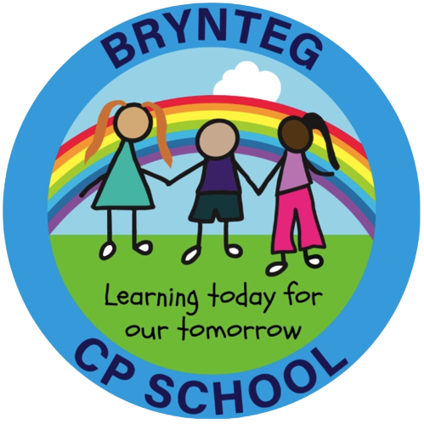

Introduction

The purpose of this policy is to set out what charges can and cannot be made for activities at Brynteg CP School. The policy has been drawn up in accordance with sections 449-462 of The Education Act 1996 which sets out the law regarding what charges can and cannot be made for activities in schools maintained by local authorities.

Education in School

No charge will be made for:
- Education provided wholly or mainly during school hours, which is part of the
revised curriculum or the Agreed Syllabus for Religious Education
- The supply of any materials, books, instruments or other equipment.

Voluntary Contributions

When organising school trips or visits, which enhance the curriculum, the school invites parents to contribute to the cost of the trip. All contributions are voluntary. If we do not receive sufficient voluntary contributions, we may cancel a trip. If a trip goes ahead it may include pupils whose parents have not paid any contribution.

If a parent wishes their child to participate in a school trip or event, but is unwilling or unable to make a voluntary contribution, we still allow the child to participate fully in that activity.

Sometimes the school pays additional costs in order to support visits. Requests for voluntary contributions will not include any element of subsidy for other pupils wishing to participate in the activity whose parents/carers are unwilling or unable to pay the costs.

The following list is an example of additional activities which may be organised by the school and which may require voluntary contributions from parents.

- Visits to museums/theatres
- Some sporting activities
- Visitors to the school such as Storytellers/Theatre Companies/Musicians

Optional Extras

The school may charge for activities defined as “optional extras” under the Education Act 1996. Optional extras are activities that take place wholly or mainly outside school hours and are not part of the National Curriculum, RE, or statutory provision.

Charges may be made for:
- Optional extra activities such as after-school clubs run by external providers
- Materials or ingredients for subjects such as Art or Design & Technology, where parents have indicated in advance that they wish to own the finished product
- Transport for optional activities taking place outside school hours
- Board and lodging for residential visits (unless the pupil is eligible for remission, as outlined in this policy)

No pupil will be excluded from an activity because of inability or unwillingness to pay. Where charges are made, they will be calculated to cover the actual cost of the activity only.

Residential Visits

The school makes parents aware of the possibility of claiming remission from the Local Authority for the costs incurred through residential visits.

Parents/Carers who can provide evidence of being in receipt of the following will be exempt from paying the cost of board and lodging on a residential visit (transport costs to and from venues will be charged for):

- Income Support
- Income Based Jobseeker’s Allowance
- In receipt of any other benefit or allowance, or entitled to any tax credit under the Tax Credits Act 2002 or element of such a tax credit, as may be prescribed by regulations from time to time for any period wholly or partly comprised in the time spent on the visit. Currently the following apply:
- Immigration and Asylum Seeker’s Allowance
- Child Tax Credit, providing Working Tax Credit is not also received and the family’s income does not exceed HMRC’s set limit (i.e. children who are eligible to receive free school meals)
- Income related employment and support allowance
- Working tax credit ‘run-on’ (the payment someone may receive for a further four weeks after they stop qualifying for working tax credit)
- Pension Credit
- Universal Credit

Charges for residential visits will never exceed the actual cost of providing the activity, and no parent will be asked to subsidise another pupil.

Damage or Loss of School Property

Parents/carers may be asked to make a voluntary contribution towards the cost of replacing items that are lost, damaged, or broken where the damage is the result of a pupil’s behaviour.

This may include:
- Books
- Equipment
- School resources
- Deliberate damage to school property

Any request will be reasonable and proportionate, and the school will not seek to profit from such contributions.

Evaluation

The Governing Body will review the Charging Policy every three years and if considered necessary, amend it.

