Brynteg CP School
School Asthma Policy



Approvals
Approved by Governing Body
Review date for Governing Body

Policy statement
This policy has been written with guidance from Asthma UK and the Department for Children, Schools and Families in addition to advice from healthcare and education professionals.
This school recognises that asthma and recurrent wheezing are important conditions affecting increasing numbers of school age children. This school welcomes pupils with asthma.
This school encourages all children to achieve their full potential in all aspects of life by having a clear policy and procedures that are understood by school staff, parents / carers and by pupils.
All staff who have contact with these children are given the opportunity to receive training from the school nursing team/specialist nurses. Updates for training are offered at regular intervals and this school will ensure attendance by staff. This will take place at least every two years and more often if there are pupils within the school who have significant asthma symptoms or there are significant changes to the management of asthma in children.

Indemnity
School staff are not required to administer asthma medication to pupils except in an emergency. However many staff may be happy to give routine medication on the advice of an appropriate healthcare professional. School staff who agree to administer asthma medication must act in agreement with this policy. All school staff will allow pupils immediate access to their own asthma medication when they need it.

What is Asthma?
Asthma is a common condition which affects the airways in the lungs. Symptoms occur in response to exposure to a trigger e.g. pollen, dust, smoke, exercise etc. These symptoms include cough, wheeze, chest tightness and breathlessness. Symptoms are usually easily reversible by use of a reliever inhaler but all staff must be aware that sufferers may experience an acute episode which will require rapid medical or hospital treatment.

Medication
Generally, only reliever inhalers should be kept in school. Usually these are blue in colour. On occasion, an older pupil (usually aged 10 or over) may have a white and red inhaler called ‘Symbicort’ which may also used as a reliever. However, they will usually have a blue reliever inhaler for use in an emergency.
Immediate access to reliever inhaler is vital. All inhalers are kept within the children’s classrooms. They are located in a position which is accessible to children and staff and all children are aware of this.

Record Keeping
When a child with asthma joins this school, parents/carers will be asked to complete a form, giving details of the condition and the treatment required. Information from this form will be used to compile an “Asthma Register” which is available for all school staff. This register will be updated at least annually or more frequently if required using the information supplied by the parent/carer.

Physical Education
Taking part in sports is an essential part of school life and important for health and well-being and children with asthma are encouraged to participate fully. Symptoms of asthma are often brought on by exercise and therefore, each child’s labelled inhaler will be available at the site of the lesson. Certain types of exercise are potent triggers for asthma e.g. cross country running and field activities. Any child who knows that an activity will induce symptoms will be encouraged to use their reliever inhaler prior to exercise, and may choose to carry it with them and will be encouraged to warm up prior to participating and cool down after

School Trips/Residential Visits
No child will be denied the opportunity to take part in school trips/residential visits because of asthma, unless so advised by their GP or consultant.
The child’s reliever inhaler will be readily available to them throughout the trip, being carried either by the child themselves or by the supervising adult in the case of infant children.
For residential visits, staff will be trained in the use of regular controller treatments, as well as emergency management. It is the responsibility of the parent/carer to provide written information about all asthma medication required by their child for the duration of the trip. Parents must be responsible for ensuring an adequate supply of medication is provided.
Group leaders will have appropriate contact numbers with them

Training
On a bi-annual basis, all staff will receive training on signs and symptoms of asthma and how to treat it.

Asthma
Education for pupils It is recommended that all pupils should be educated about asthma. This could be through PSHE, drugs education, assemblies etc.

Concerns
If a member of staff has concerns about the progress of a child with asthma, which they feel may be related to poor symptom control, they will be encouraged to discuss this with the parent/carer and/or school nurse.

Storage of Inhalers
The following good practice guidelines for the storage of inhalers will be followed:
- Inhalers will NEVER be locked away or kept in the school office.
- All children with asthma will have rapid access to their inhalers as soon as they need them
- Devices will always be taken with the child when moving out of the classroom for lessons, trips or activities.

In the unlikely event of another pupil using someone else’s blue inhaler there is little chance of harm. The drug in reliever inhalers is very safe and overdose is very unlikely.

Emergency Procedures
This flow chart outlines the action to be taken in an emergency:
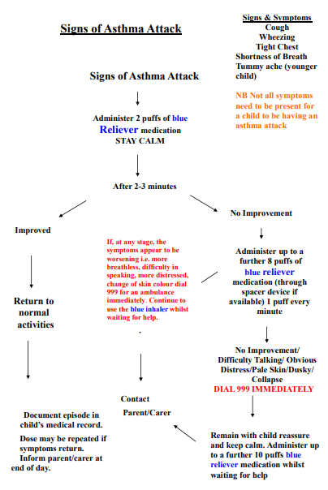
Good practice suggests that copies are printed and displayed in the school office, staff room and relevant locations including classrooms where a pupil is known to have severe asthma.
If a child has Symbicort (white/red inhaler) the maximum dose that can be used in an emergency is 4 puffs 1 minute apart. If symptoms do not settle and no blue reliever inhaler is available call 999 and ask for an ambulance. If a blue reliever inhaler is available follow flow chart.
Responsibilities
Parents/Carers have a responsibility to:
- Tell the school that their child has asthma.
- Ensure the school has complete and up to date information regarding their child’s condition.
- Inform the school about the medicines their child requires during school hours.
- Inform the school of any medicines their child requires while taking part in visits, outings or field trips and other out of school activities.
- Inform the school of any changes to their child’s medication.
- Inform the school if their child is or has been unwell which may affect the symptoms e.g. symptoms worsening or sleep disturbances due to symptoms.
- Ensure their child’s inhaler (and spacer where relevant) is labelled with their child’s name.
- Provide the school with a spare inhaler labelled with their child’s name.
- Regularly check the inhalers kept in school to ensure there is an adequate amount of medicine available and that it is in date.
All school staff (teaching and non-teaching) have a responsibility to:
- Understand the school asthma policy.
- Know which pupils they come into contact with have asthma.
- Know what to do in an asthma attack.
- Allow pupils with asthma immediate access to their reliever inhaler.
- Inform parents/carers if a child has had an asthma attack.
- Inform parents if they become aware of a child using more reliever inhaler than usual.
- Ensure inhalers are taken on external trips/outings.
- Be aware that a child may be more tired due to night time symptoms.
- Liaise with parents/carers, school nurse, ALNCO, etc. if a child is falling behind with their work because of asthma.
Review
This policy will be reviewed every three years or when new guidance is made available.

